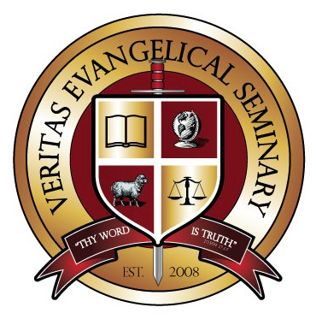
Veritas Evangelical Seminary
2013 Student Services Survey

VES Student Services is very interested in your experience with the services offered by our staff and the level of satisfaction, and desire to better understand and minister to your needs.

Instructions: Write in the space provided the number that most accurately expresses your response using the scale provided. If you wish to respond further to any of the questions, write the number of the question with your comments on a separate page.
1- Strongly Agree 2- Agree 3- Disagree 4- Strongly Disagree 5- Don’t Know

The VES Student Services staff were:
- ___ Helpful and friendly
- ___ Competent and informative
- ___ Able to assist with your needs in a reasonable timeframe
- ___ Courteous and understanding
- ___ Able to communicate with you satisfactorily
- ___ Were able to refer you to the appropriate departments when needed
- ___ Helpful in both verbal and written communication
- ___ Available to you with convenient working hours

The VES Student Services staff offered:
- ___ Knowledgeable direction and counsel
- ___ Pertinent employment/ministry/ volunteer opportunities
- ___ Information regarding conferences and events
- ___ Career counseling and job placement assistance

What was the strongest area of service made available to you by the Student Services staff?

What area most needs to be improved within Student Services?

Did the scope and effectiveness of the services available meet your needs?

Any other comments.

